

·METAL & SCALES·

by Ben Head

Location: The Old World Battle-Level: 3-4 Objective Room: Any

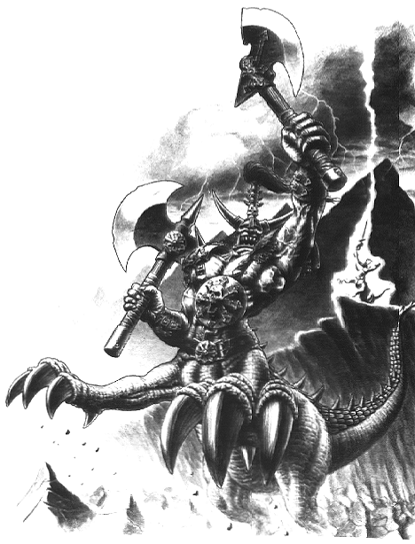
Passing some travellers on the road, the Warriors learn that a hellish beast around these parts has been wiping out nearby villages. It is said to have thick scales, a great size and is living in a nearby cave. The Warriors are weary after their travels but know this creature must be put to death. Trudging through the undergrowth they come to the entrance of a cave cut into the hillside. Around its entrance lie scattered weapons and what appears to be blacksmith’s forge with a half-made breastplate leaning up against it. The Warriors find the weapons to be unfinished and unusable and they make their way into the cave.

SPECIAL RULES

Play the adventure as normal, with the following modifiers. When entering a new Dungeon Room roll 1D6. On a 5-6 this room has a piece of equipment in it and may be taken by a Warriors. Randomly choose an item from the Armoury location in the Roleplay Book. If the dice rolls a 1, then their next roll of this kind is void.

Completion

When the Warriors enter the Objective Room they are greeted with a fearsome sight. A mighty Dragon Ogre is pounding away on a forge at the back of the room. He turns with a wry smile on his face and grabs his weapon, grateful for some recreation after a hard days work. Roll on the Objective Room Monster Table as normal. In addition place a Dragon Ogre at the rear of the room, and a counter to represent a forge (2x2 squares). Once the battle is won each Warrior may randomly select an item from the Armoury location in the Roleplay Book for an item. In addition if the Objective Room Treasure card is armour of some sort, any magical properties it has are doubled.

