

NIGHT OF THE GORGONS

by Ben Head

Location: The Old World Battle-Level: 3-5 Objective Room: Any

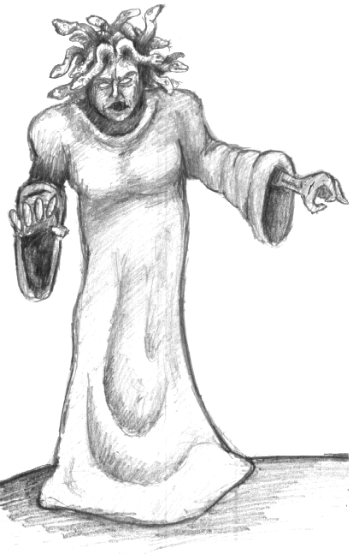
Trudging though the night, the Warriors come to the outskirts of a small village. Hoping for some comfort from the cold they make their way in. Before they even take more than ten steps they begin to see them - statues of bodies, people, fill the area, some in positions of attack, some covering defensively, but all stone. Sensing foul play they proceed cautiously, with an eye out for who or what did this. Before long they come to what looks like a shrine, littered with different foods around its base. Standing in front of it stands a robed figure with it’s back to them, rummaging through it.

At the Warriors approach, the figure turns around to reveal a horrific looking woman with writhing snakes in place of hair. Suddenly her eyes burn with a bright blue light. A random Warrior is gripped by her gaze and must roll 1D6. On a 1 he begins to turn to stone, and must subtract -1 Move for the remainder of the adventure. Now fight a battle with one Gorgon.

Once the battle is over the Warriors look to the shrine for anything of value. They find nothing but a roughly engraved map, copying it down roughly on a piece of parchment.

If the Warriors wish to follow the map till its end, read on, otherwise the adventure ends now.

Roll 1D3 times on the wilderness chart to symbolize the journey. Once the journey is completed the Warriors find themselves at the entrance of an abandoned temple.

Surrounding the entrance is a macabre garden of warriors turned to stone.

If the Warriors still with to go on, they push back an excess of vines and enter.

Make a dungeon deck as normal. When entering a new room roll 1D6 on the next table as well as the usual events:

Gorgon Table
1-2 The room is inhabited with 1 Gorgon, who attacks the Warriors, as well as any other Monsters or Events.
3-4 The room has 1D3 stone adventurers in it - place them randomly. The statues block movement but can be pushed/pulled into adjacent squares by sacrificing all attacks for one turn. Add +1 to the next roll on this chart (cumulative until a 1-2 is rolled).
4-6 Treat this room as normal.

Objective Room
As well as the normal Monsters, there are 1D3+1 Gorgons in this room. In addition, all Warriors must roll 1D6. For every dice with a 1 as the result add an additional Gorgon to the battle. There are also 1D3+1 stone statues of the Gorgons victims. Place randomly with the same rules as stated on the 3-4 result on the Gorgon table.

At any time throughout the dungeon, not in battle, a Warrior may attempt to sever a Gorgons head - roll 1D6. On a 1-2 the Warrior must suffer the Petrify rule.

At anytime per adventure the Warrior may try and utilize the Gorgon’s power by taking it from his belongings and showing it to any adjacent Monster. Roll 1D6 when this happens. On a 1 the Warrior has glanced at the heads face by accident and must suffer the Petrify rule as usual. On a 5-6 the Monster is turned to stone and remains on the square, blocking movement in his current position. A Gorgon’s head will last for 1D2 adventures.

Once the Objective Room has been completed the Warriors gain 350 Gold each as well as the normal treasure. This is littered around the room, trophies of the Gorgons victims.

