

NIGHT OF THE UNDEAD

by Ben Head

Location: The Old World Battle-Level: 1-2 Objective Room: Dread King’s Throne Room

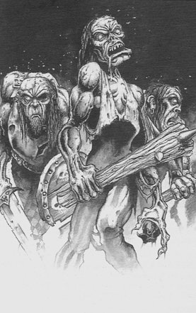

The Warriors have been summoned to the court of Marienburg, a prominent city on the outskirts of the Empire. After their journey the fatigued adventures were hoping for a warm reception, but what greets them is empty streets and frightened people slamming their shutters closed as the Warriors walk through the town. It is dusk and even in the dim light, the Warriors can make out a faint hint of scarlet; colouring the water running between the cobblestones under their feet.

Soon the great hall is reached and a solemn looking gentleman, obviously the head of the guard, greets the Warriors. “My name is Gorion and I’m glad you’re here”, he begins in a voice failing to conceal the graveness of the situation. The Warriors soon find out from Gorion that Marienburg is repeatedly being assailed by undead and other such beasts. People are too afraid to leave their homes from fear of facing death itself. And this very night they have been asked to rid this death from the town. Gorion tells them that it originated from the graveyard just on the edge of town. His guard fought them for many weeks but eventually fled in fear of that which could not be stopped. “We will travel there now” he says, “and may Sigmar be with us!”

Reaching the fence of the graveyard the Warrior can already see the familiar shapes of shambling undead milling around the grave moaning unnervingly.

Entering the Graveyard
Use the Great Hall to represent the graveyard. Where there are pillars, take these to be tombstones. Place the Warriors at one end of the graveyard, as they would normally start a dungeon. Also add Gorion who will fight as any other Warrior. Now roll 1D3 for each Warrior and Gorion, and add them together. This is the amount of Zombies staggering around the graveyard. Place them randomly. Once they are places play the Graveyard as a normal room with monsters.

Gorion must be treated as if he is another Warrior taking his fair share of Gold. However, he is not eligible for treasure because he curses it as being from the hands of the evil dead. A player can control Gorion, moving him after all the other players have had their turns.

 | Gorion
Wounds | 10
Move | 4
Weapon Skill | 3
Ballistic Skill | -
Strength | 3
Toughness | 3(1)
Armour | 1
Initiative | 3
Attacks | 1
Damage | 1D6
Willpower | -
Luck | -
Pinning | 5+

ENEMY’S WS 1 2 3 4 5 6 7 8 9 10
Gorion 2 3 4 4 4 4 5 5 5 6

Gorion
Armed with Sword.

Once the undead have been dispatched, the Warriors make their way to the mausoleum in the center of the graveyard. Entering cautiously, they find a stairway to a lower level.

Play a Dungeon as normal except when an event reveals Monsters, in which case roll 1D6. On a 1-3 the Monsters are 1D6+2 Zombies. On a 4-6 roll for Monsters as normal.

Objective Room
Once the Warriors have reached the Objective Room place a Necromancer at the rear of the room. This is an acolyte in training and does not know the full range of Necromantic spells. Instead he can only cast Raise Zombies or Raise Skeletons each turn from the surrounding corpses in the Mausoleum. Any Skeletons raised will Guard him. His Gold value is 600. Also in the Objective room is 1D6+6 Zombies and 1D6 Skeletons.

Completing the Objective Room
Once the Necromancer and his creations have been vanquished it is discovered that there is a small chamber in the rear of the room. Inside are books and scroll and a make shift living area. After some searching it is clear that the Necromancer was an outcast of the Wizards Guild in Marienburg. He wished to seek vengeance on the town and all who lived there by dabbling in the black arts and coaxing other monsters into the bowels of the Mausoleum. If Gorion is still with you he escorts you back and rewards the Warriors with 300 Gold each.

