

·SCARLET ICE·

by Ben Head

Location: Norsca Battle-Level: 5-8 Objective Room: The Frost Demon’s Throne Room

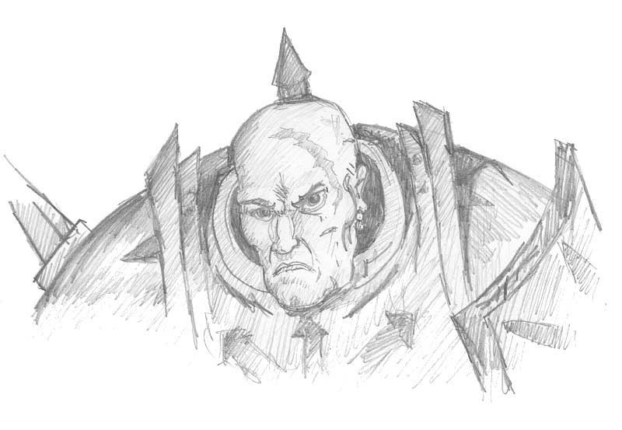

Whilst in the Waterfront Tavern the Warriors are approached by an armour-clad woman, introducing herself as Loren, a Valkyrie of the north. The Warriors, hands on their hilts, cautiously accept her company as she seats herself in a somewhat urgent manner.

“Judging from your scars, it is obvious that you are no strangers to battle” she begins. “I come to you with a request for assistance. No doubt you have heard of the great Norse Marauder, Katan.” The Warriors recall such a legend as Katan easily. It was said that Katan was to take over all of Norsca at one stage with his mighty army of Chaos Marauders. His magical armour renowned for its purple glow was said to heal his Wounds almost instantly. He was beaten back by wave after wave of brave Norse Barbarians, Valkyrie’s and Hardoon (White Minotaurs). Katan escaped with his best troops to a hideout in the mountains never to be seen again. Loren’s eyes narrow as she bitterly whispers, “Katan has re surfaced! My sisters and I spotted his foul band on route to this very city! We intercepted him but were butchered. Myself and a few others are all that remain,” she says waving her hand to table of Warrior women in the corner nursing recent wounds. “We have reason to believe he is planning something big! Please, he must be stopped, will you help us?”

If the Warriors agree read on.

Loren is pleased and continues. “We must know what he is planning and where he is going next. We know he is in a disused warehouse on the outskirts of this city at the moment, preparing for travel. This is where you come in. You are going to have to infiltrate Katan’s group and join him to his destination. We realize this will be extremely difficult but the entire fate of Norsca may be in jeopardy. We can track you by means of an ice falcon - don’t let anything happen to the falcon or we wont know where you are headed. You must find out what he is planning. While you are journeying with Katan, my sisters and I will be rallying barbarians and Hardoon.” Loren takes the Warriors to the warehouse quickly; already they can hear deep voices and the clanking of metal resonating from within. “Go now,” Loren urges. “We will meet you at your destination! May Odin be with you!”

SPECIAL RULES

The Warriors now stand in front of a huge warehouse, readying themselves to play murderers and cutthroats in an attempt to be accepted into Katans band. They push open the double doors and stroll in.

Katan and his group look up savagely at their entry and grab their weapons.

Roll 1D6, adding +1 for every Chaos Warrior in the party.

1 One of the Warriors begins to say, “We’d like to joi…” but is cut short by battle cries as they are charged! The battle is short, resulting in the Warriors taking 4D6 Wounds each and being thrown outside. The double doors shut behind them with the sounds of laughter. They may try and enter again if they wish, with a –1 modifier or walk back to the tavern, beaten.

2-3 “Intruders!” shouts one of Katan’s guards as they stand to their feet. They stand their ground as the Warriors move in. What’s your business?” states Katan at a random Warrior, in a deep commanding voice. The Warrior gulps and tries to answer as best he can. Roll 1D6:

1-2 The Warrior is very shaken by Katan’s presence and freezes up. “We’re here to… sell cookies… that’s it.. You don’t want any… so we’ll be going now…” With that they are thrown out of the warehouse to the sounds of laughter. They may try and enter again if they wish, with a –1 modifier or walk back to the tavern, beaten.

3-6 The Warrior requests to join up with him. Katan looks the Warriors up and down, “I have no room for free loaders and I only use the best. You looks like you could hold your own in a fight. Tell you what, if you can beat Destroyer here, you can join. The Warriors breathe a sigh of relief, 4 against one, that should be easy. Then, in front of them stands the massive bulk of Destroyer. All the Warriors look up… and keep looking up until they reach his one eyed head. Destroyer launches into battle surprising the Warriors and giving him an automatic Ambush. Destroyer is an Orgut, those who have been to Nehekhara would know of his breed. Fight a battle with Destroyer. (Statistics are located at the end of the document)

If the Warriors win they are accepted into the group. Katan throws some dust over Destroyers body that looks like sand and he is resurrected, his eye looking vengefully at the Warriors.

4 The Warriors enter the room cautiously and find themselves surrounded quickly! “We are here to join you Katan” says one of the Warriors. “Really?” interjects Katan, “For what purpose?”

Roll 1D6 for the Warriors response:

1 “So we can all get rich of course!” he blurts! Katan shakes his head and the Warriors are pushed outside. They may try to enter again.

2 “For the glory of Norsca!” Katan frowns and the Warriors are pushed outside. They may try to enter again.

3 “For the glory of Chaos!” Katan looks into the Warriors eyes, “and what else?” Roll again on this table.

4-6 “For my lord and master Katan to rule the world!” Katan seems happy with this answer and he accepts the Warriors.

5 “Katan, we wish to join you” shouts a random Warrior. “Do you now?” Katan replies in a deep voice. “Well I don’t accept just anyone into my group, although you do look like you could handle yourselves. If each of you can beat Vron here in an arm wrestle, you can join.” Vron sits at the table awaiting the Warriors. He is adorned in green and gold armour and appears to have an animated skull for a head. Each Warrior in turn must roll 1D6 and add his Strength. Now roll 1D6 and add Vron’s Strength of 5. If all Warriors win against Vron they are accepted (a Warrior will win on a tie). If not, then they are pushed outside, the double doors shutting behind them with the sounds of laughter. They may try and enter again if they wish.

6 The Warriors enter boldly, and all call “Hail Katan” in unison. Katan looks puzzled for a moment, then a wry smile appears on his grim features. “New recruits!” he says in a rumbling voice before he bellows in laughter! The Warriors are wondering what they have gotten themselves into. They have been accepted.

Once the Warriors have been accepted into Katan’s party.

Once the Warriors are accepted they are introduced to the band of marauders they are now a part. There is Katan, a mighty bald headed legend, adorned with a magical purple plate armour, and a severed head hanging from his belt, showing of a bloodied past. Then there is Destroyer, a giant bloated one-eyed creature from the wastes of Nehekhara. Then Vron, Katan’s second in command, adorned with green amour. The rest of the band consists of Chaos Warriors and the like.

At any time during the adventure the Warriors may attack Katan and his band. Simply fight a battle with Katan, Vron, Destroyer and 1D6 Chaos Heroes. But if they do, they must lose 1 Permanent Luck point for going against their word and betraying Norsca by not finding out Katan’s plans.

Just before morning the band set off. They seem to be heading off into the mountains; above they can hear the shrill cry of an ice falcon. Roll 1D6+3 for the amount of weeks spent journeying. Each week roll 2D6 on the Travel Table.

Travel Table

2 Katan decides to test a random Warriors loyalty. If the Warrior refuses then they must attack as stated above. Roll 1D6:
1 Katan orders him to give him a treasure card.

2 Katan orders him to cut himself in the name of chaos. If he does roll 1D3. This is the amount of Permanent Wounds lost. These will be regained next adventure.

3-4 Katan orders the Warrior to give him all of his provisions.

5-6 Katan orders the Warrior to sing a tale in his honor.

3 Destroyer pushes a random Warrior into a rock in the snow, bellowing in laughter. He takes 1D6+4 damage. Rising to his feet, the Warrior is very angry. Roll 1D6 and add the Warriors Willpower. If the result is 9 or more then he has kept his cool, otherwise he retaliates - roll 1D6:

1 The Warrior has had it with this huge lard ball! He pulls his weapon out and brandishes it. Unfortunately he is still dazed from the fall and is facing the wrong way. Destroyer smashes his hammer like fist onto his head, sprawling him on the snow once more. The Warrior takes 3D6 damage. The brute then walks on.

2 The Warrior is fed up and goes to kick Destroyer in the shin. Unfortunately he slips, banging his head causing 1D6 damage and Destroyer just steps over him, chuckling to himself.

3-4 The Warrior picks up a rock and throws it at Destroyer. It seems to annoy him for a moment, but then he smiles. “I like you,” he says in a crude, booming form of common. He then continues on. The Warrior shrugs his shoulders and walks on also.

5-6 The Warrior goes to pick up a rock and throw it but instead he grabs a snowball by accident and throws it at Destroyer. It falls against him pitifully. He looks confused for a moment, then bellows in laughter. “You make Destroyer laugh!” he booms. He then pats the Warrior on the head. “Funny man.” From now on, Destroyer won’t pick on this Warrior.

4 Katan spots the ice falcon high in the sky and commands a random Warrior to shoot it down with a crossbow he has. Katan is hungry! Now the Warrior can aim for the Falcon and just hope he misses or try to miss on purpose. If he tries to miss on purpose he can subtract –2 to his Ballistic roll, but there is a greater chance that Katan will notice. If the falcon is hit it spirals down to the group where it is eaten that very night! The Warriors hope Loren will be able to find them by other means. If the Warrior misses, Katan frowns and walks on. If the Warrior missed on purpose roll 1D6. On a 1-3, Katan notices - go straight to result 2 on this table.

5 Katan sends a random Warrior and Vron to go hunting for food. Roll 1D6:

1 Vron hunts maliciously, hammering wild beasts into the ground with his hammer. The Warrior has trouble keeping up and comes back empty handed. Vron strolls into camp with four dears on his shoulders and dragging a snow leopard behind him. Katan is displeased with the Warrior’s inability to perform even the simplest task. As a penalty the Warrior may not eat for 1D3 weeks. Each week 1D6 unmodified damage is taken, including this one.

2 The Warrior isn’t up to his usual standard missing many easy targets. Vron on the other hand beats his prey to a plup and brings it back to camp. The Warrior brings his small wolf back and throws it on Vrons heap. “I will not tolerate free loaders!” Katan bark and sends the Warrior out to find more. He comes back eventually with two deer. But hunting through the night in the intense cold has taken its toll. He is at –1 toughness for the remainder of the journey.

3-5 The Warrior manages to keep up this Vron taking in almost as many kills. Katan is pleased with his ability and gives him a nod.

6 The Warrior leave Vron for dead collecting twice as many deer and seals. Katan Is most pleased and gives him a fine helping of food, giving him 1D6 Wounds back. “there is a place for a man like you in my army” he says. “keep up the good work, there are many command positions open.

  - The Warriors manage to keep out of Katans way this week.

8 The band come to a rope bridge, its fibres cracked with ice. A deep chasm seems endless underneath. Katan points for a random Warrior to test it. That Warrior edges his way forward looking over at what may be a grisly death. Roll 1D6. On a 1 the Warrior falls to his death, the bridge breaking underneath him. The journey then takes another week to go around the chasm. On any other number the bridge is safe and they may continue.

9 The Warriors have a hard time keeping up with Katan and his group. A random Warrior suffers heavy fatigue. Roll 1D6 and add his Toughness. If the result is 7 or greater he manages to keep up, otherwise he loses 2D6 unmodified Wounds.

10 The journey goes smoothly and Katan is satisfied with the Warriors performance.

11 During the night a random Warrior hears Katans voice just outside of camp. Perhaps he is talking of plans, perhaps not. Still, the Warrior should find out. If he wishes to find out then he makes it over to where he heard the voice. Roll 1D6:

1 The voice was indeed Katans, but he is just muttering something and seems to be relieving himself. Not wanting to be discovered the Warrior hurriedly makes his way back to camp.

2-3 The voice didn’t belong to Katan at all. Instead the Warrior sees Destroyer with a seal up in the air torturing it with various implements. Not wanting to be discovered the Warrior hurriedly makes his way back to camp.

4 Although the Warrior is where he heard the voice, he now hears nothing, but he notices a pile of rocks at his feet. Shrugging he makes his way back to camp.

5-6 The voice was indeed Katans and he is talking to Vron who remains silent. “I don’t trust these Warriors, Vron. Keep an eye on them - we can’t have our mission jeopardized. We will be at the unholy temple soon to meet our brethren, then the treasures of this world and the next will be ours!” Then the Warrior carelessly snaps a twig under his boot, and hurries back to camp.

12 Travel fairs well this week and the group manage to commandeer a small boat to take them down river. – 1 week from journey time.

Once the Journey is Completed

Finally the band of travellers come to a dungeon entrance.

“Halt!” commands Katan. “Inside this dungeon lies an artifact I wish. To test your loyalty I want you,” he says, pointing to the Warriors “to go and retrieve it. I will not tolerate failure.”

The Warriors must play an Ice Cavern of 8 Dungeon Cards and an Objective room. Divide the Dungeon Cards in half and shuffle the Objective Room into the bottom 4 like a normal adventure. If the Warriors flee, they stumble out to where Katan is and must fight his band as punishment for failure. Once the Objective room is reached and completed the Warriors see a great glowing artifact at the end of the room. It resembles a mighty orb that glows intently as the Warriors approach. They take it and leave the Ice Caverns back to Katan.

Katan seems pleased when they approach, taking the orb. “You have done well, very well. As a reward I, Katan allow you to keep whatever other treasures you found within. Now, Onward!”

Again the group move off. Make another 1D6+1 rolls on the travel table above.

Once this Journey is Completed

The Warriors see a mighty temple rising up before them, a black spire on the landscape that grows as they approach. As they skirt the rim of a cliff just before the temple, they look down to see what must be thousands of Chaos Warriors moving around almost like ants. Each Warrior gulps at the sight. Chaos warriors on Chaos Steeds ride up to Katan and supply him and the Warriors with chariots, which they ride to the temple in. As they pass the chaos hordes, the name of Katan is shouted loud. Katan dismounts at the temple steps, Vron beside him, and raises the orb into the air as a mighty roar erupts from the crowd. The Warriors keep to the side but are still cheered at like heroes.

Two days pass…

The Warriors lay low in the masses, keeping to themselves, waiting for the Valkyries and other warriors to appear. In the middle of the third day Katan emerges from the Temple with the orb and places it on an altar. He takes a step back as two Chaos Sorcerers take his place and begin chanting. The orb glows brighter and brighter. Just when the Warriors think it is about to explode a horn trumpets in the distance, the battle horn of the Valkyries! They look back to the cliff and see a veritable army charging down towards them, Valkyrie, Norse and Hardoon together. The battle is on!!

Suddenly Chaos Warriors are swarming everywhere, grabbing weapons preparing for the onslaught. Katan, Vron and the sorcerers retreat inside the temple with the orb. The Warriors realize now is their chance to kill Katan and push their way past the hordes to the steps of the Temple. They are about to enter when Destroyer steps in front of the entrance with Chaos Warriors in tow. They have no choice but to cut their way though. Fight a battle with Destroyer and 2D6 Chaos Heroes.

Once dispatched, the Chaos Warriors enter the temple. Make up an Ice Cavern with 6 cards and an Objective room. Shuffle the Objective Room into the last 3 cards as normal. While adventuring, if Monsters are encountered, roll 1D6 on the following table instead of the normal Monster tables in the Roleplay Book.

- 1 Chaos Lord; 1D6 Chaos Heroes; 2D6 Chaos Champions.
- Chaos Master Sorcerer; 1 Chaos Lord; 1D6 Chaos Champions.
- Chaos Sorcerer Champion; 1D3 Chaos Trolls.
- 1D6 Chaos Heroes; 1D6 Chaos Champions.
- Chaos Master Sorcerer; 1D3 Chaos Champions.
- 1D6 Chaos Champions.

Once the Objective Room is reached, place Katan at the rear on the throne, then Vron beside him. Also place two Chaos sorcerers at the rear, then roll on the table above. Katan and Vron will attack as normal. Do not use the rules for the Objective Room as stated on the Dungeon Card.

Once the Warriors kill Katan and clear out the Objective Room, they retrieve the orb. Heading back out they survey the battle! If the ice falcon was killed then only half of the troops managed to find the temple, and they have not yet won the battle. The Warriors must help them, cleaving their way though the remaining Chaos Warriors and receiving 3D6 Wounds damage in the process before the deed is done. If the ice falcon survived then all the troops found the location and the Warriors emerge to see the battle to be won! The last remaining Chaos Warriors can be seen fleeing over the snowy cliffs.

Loren, bloody from battle charges over to the Warriors with two Hardoon as escort. “Thank Odin you are safe my friends, and you have the orb! You will be well rewarded for this!” The Warriors head back to the Valkyries settlement where they are each healed fully and given 1D6 provisions, 1000 Gold and an Objective Room Treasure Card. They must now journey to another Settlement as normal.

Character Statistics

Katan
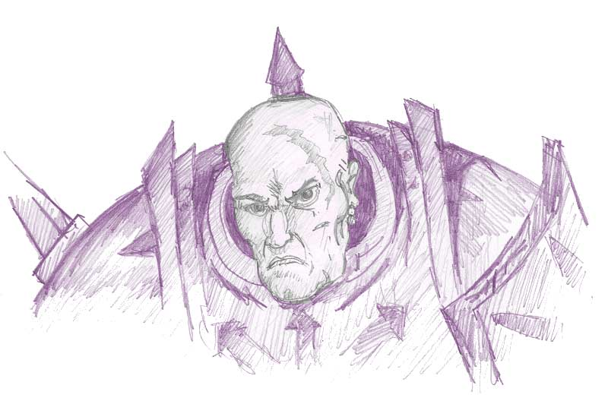
Wounds | 80
Move | 5
Weapon Skill | 8
Ballistic Skill | 4+
Strength | 6
Toughness | 5 (13)
Armour | 8
Initiative | 9
Attacks | 5
Damage | 3D6
Gold | 4000

ENEMY’S WS 1 2 3 4 5 6 7 8 9 10
Katan 2 2 2 3 3 3 3 4 4 4

Katan

Armed with Axe of Decapitation; Death Arc; Endure; Fear 10, Ignore Blows 5+; Regeneration 2.

Axe of Decapitation
When Katan rolls a 6 to hit roll 2D6. If a double is rolled the Warrior is decapitated instantly. No healing can restore the Warrior to 1 Wound in this case.

Death Arc
If more than 2 Warriors are adjacent to Katan he swings his mighty axe in a death arc, making 1 attack against all adjacent Warriors before he begins his normal attacks.

Endure
When Katan reaches 0 Wounds roll 1D6. On a 5-6 he has managed to withstand the fatal blow and is placed back on 1 Wound. Warriors do not receive further Gold for felling him subsequent times.

Vron
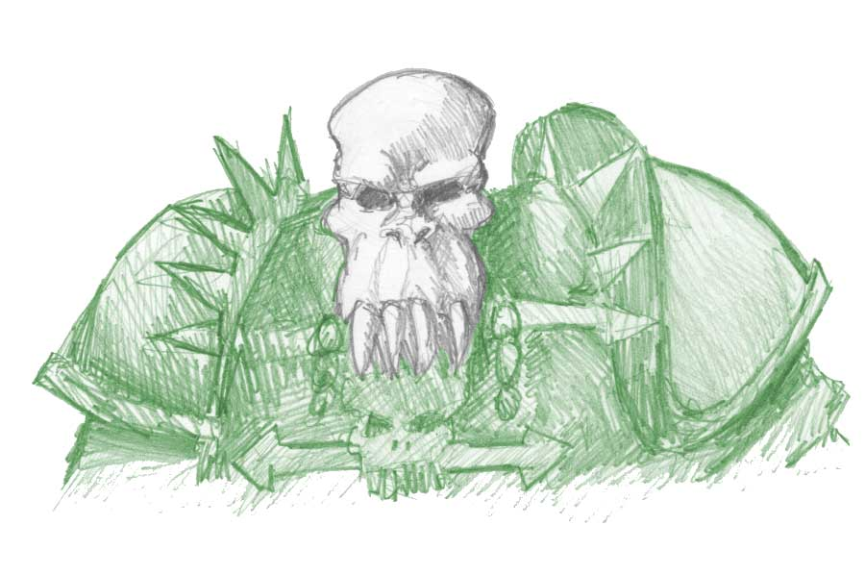
Wounds | 60
Move | 4
Weapon Skill | 7
Ballistic Skill | 4+
Strength | 5
Toughness | 5 (11)
Armour | 6
Initiative | 6
Attacks | 4
Damage | 2D6
Gold | 2000

ENEMY’S WS 1 2 3 4 5 6 7 8 9 10
Vron 2 2 2 3 3 3 4 4 4 4

Vron

Ignore Blows 6+; Knockout.

Knockout
If Vron rolls a 6 to hit he inflicts normal damage and whacks the Warrior directly on the head. If the Warrior is not wearing a helmet he is knocked unconscious for 1 turn where he are treated as prone. If a helmet is being worn, however, roll 1D6. On a 1-3 he is knocked unconscious anyhow for 1, as above.

Destroyer
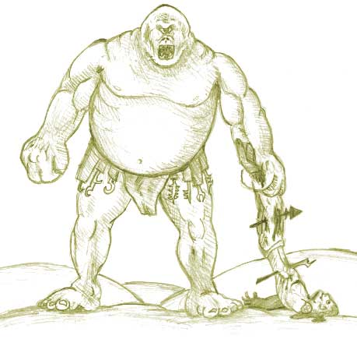
Wounds | 50
Move | 4
Weapon Skill | 7
Ballistic Skill | 4+
Strength | 8
Toughness | 6
Armour | -
Initiative | 5
Attacks | 2
Damage | 3D6
Gold | 1200

ENEMY’S WS 1 2 3 4 5 6 7 8 9 10
Destroyer 2 2 2 3 3 3 4 4 4 4

Destroyer
Fear 11; Torture.

Torture
If and when Destroyer rolls a six to hit, roll 1D6. On a 1-3 work out the damage as normal. On a 4-6 the blow has hit the Warrior squarely on the head (inflicting normal damage) and has knocked him into a daze. Once the Warrior is dazed Destroyer picks him up and takes him to a square that is out of range of the other Warriors (breaking all pinning). When he is somewhat free of the battle he begins to torture the Warrior. First roll 1D6 for how many turns the Warrior is dazed, then for each of these turns roll on the following table.

Torture Table

1 Destroyer spends the turn gathering torture implements from his belongings (usually on his belt). He adds +1 to next torture roll.

2-4 Destroyer twists and stabs at the Warrior’s body in various ways, chuckling cruelly. The Warrior takes 1D6 unmodified damage.

5-6 Destroyer skewers and tears at the Warrior making him wince and call out in pain, much to his torturers delight. The Warrior loses 1 Permanent Wound.

Once the Warrior comes out of his daze he crawls into an adjacent square where he continues to fight as normal. If there are no adjacent squares then the Warrior crawls into the nearest one.

If Destroyer is attacked by another Warrior while he is torturing, his attention is diverted to the attacking Warrior, leaving the Warrior being tortured to crawl away in his dazed state to an adjacent square as above where he waits out the rest of his dazed state. While dazed he is classed as being prone.

If Destroyer is adjacent to a dazed Warrior and he is not attacking or being attacked by any other Warriors, he will immediately pick him up and start torturing the dazed Warrior as normal.

