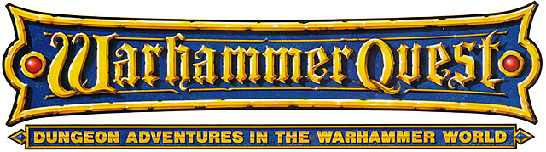

·SOLOMON’S KEY·

by Andrew Brockhouse
(adapted from a HeroQuest adventure by Christopher Brockhouse)

Location: The Old World Battle-Level: 1-2 Objective Room: Any

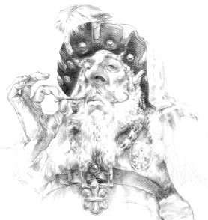

King Solomon was the King of the realm, and a wealthier king no one had ever seen. The Treasure Chamber of his castle contained 999,999 Gold and a Golden Key. The Key opened a small box in King Solomon’s bedchamber, which contained the largest jewel in the land. Two guards constantly stood by the entrance to the treasure chamber, guarding it from thieves.

One day, King Solomon decided to go and count his Gold, but upon arriving in the treasure Chamber was shocked to find it empty! All that was there was a crude note pinned to the wall saying.

“Ha ha ha. I have your Key and all of your Gold. If you ever want to see them again come to my hideout and perhaps we can arrange a deal.”

King Solomon was having none of this though! He immediately hired the Warriors, who just happened to be passing through his realm, to go and retrieve his Gold and his Key at all costs.

SPECIAL RULES

Play this adventure as normal. Upon reaching the Objective Room the Warriors will find an enormous pile of Gold, obviously belonging to King Solomon. They also see his Golden Key hanging nearby. A Dark Elf Assassin stands in the room, protected by Objective Room Monsters.

“Ha ha ha. I see the cowardly King Solomon has sent you buffoons to do his bidding. No matter, I will carry out my original plan.”

And with that, the Assassin springs at the Warriors. Roll for his Ambush special ability to determine if the Warriors were ready for his attack.

Conclusion

If the Warriors kill the Dark Elf Assassin, somehow they manage to take all of the Gold and the Golden Key back to King Solomon. He gratefully rewards each of them generously with 100 Gold. Aren’t the Warriors glad they returned all of the Gold for such a huge reward?

