

·THE BLACK TOWER·

by Andrew Brockhouse

Location: The Old World Battle-Level: 2-10 Objective Room: Wizard’s Study

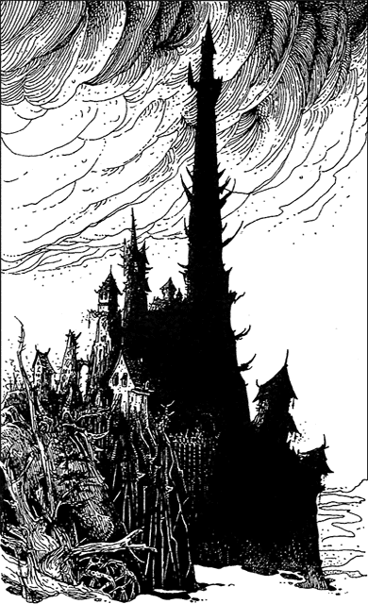
In the dead of night the Warriors had agreed to come to the Dark Tower. And all because of that strange wizard in the alehouse. Why they had listened to his story they don’t recall – they had heard many similar stories, but for some reason, none had intrigued them as much as the tale last night. The wizard had told of the Dark Tower, a place of forbidding evil on top of the hill just outside the settlement. Many adventurers had been to the tower, but none have ever returned. Passers by had told of hideous beasts, glimpsed through the windows of the tower, and strange sounds coming from beyond the stone walls. The wizard also told the Warriors about a demonic Chaos Sorcerer who lived in the very top of the tower. The locals had put up with him for years as he had never actually caused them any harm, but recently the reports of the strange beasts had increased. The wizards involvement in all of this was that he would like to get his hands on the Chaos Sorcerer’s magical ingredients. He had hired the Warriors to retrieve them from the Chaos Sorcerer, knowing full well that their lives would be in great danger.

And now the Warriors stand at the gate of the Black Tower. They must have been mad, or drunk, to agree to the wizard’s terms; in return for the magical ingredients, they could keep whatever other treasure they found. Since they would have kept all the treasure anyhow, the deal doesn’t sound as sweet as it did last night, and considering the ingredients are in the top room of the tower…

Pushing open the enormous doors, the Warriors enter…

SPECIAL RULES

Because of the shape of the tower, the dungeon deck is constructed differently than normal. Remove all T-Junctions and other rooms with multiple exits from the deck beforehand (such as the Room of Death). Shuffle 12 Dungeon Cards together, but do not place the Objective Room in the last 6 as usual. Divide the cards into separate decks of 6 cards, 4 cards and 2 cards, with the Objective Room at the top. This represents the shape of the tower, culminating in the single room way at the top. An example dungeon layout might look like this:
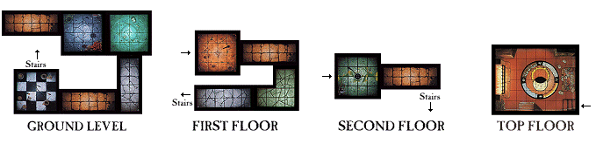
Play the adventure as normal, except at the end of each ‘level’, just start a new section of dungeon to represent the levels of the tower going up. Warriors can still travel between the various sections using stairs that are assumed to be at the end of each tower section. When the Warriors reach the Objective room, don’t place Objective Room Monsters just yet, but instead read the following.

The Warriors finally reach the Wizard’s Study and are puzzled by what they see. The strange wizard from the Alehouse is sitting in a high backed chair near a window. At the Warrior’s entrance he looks up. “Ah, you have finally made it. I was wondering how long it would take you to get here. I see you are shocked. What am I doing here you are probably going to ask? Well, I will tell you. Remember that demonic Chaos Sorcerer I was telling you about, well I am he!” And with that startling revelation he leaps to his feet. “I needed the bravest warriors to experiment upon, the local townspeople are fairly stupid, and their intelligence would not suit what I had planned for them. But you,’ he says, pointing at the Warriors. “You will suit my experiments just fine.” And with that last outburst the Warriors notice disgusting piles of flesh littered around the room, pulsating and glowing. Some piles have huge claws extending from them while others have huge sores full of pus. Suddenly the piles of flesh start to move and with horror the Warriors realise they are deadly Chaos Spawn!

Place 2D6 + 2 Chaos Spawn in the Wizard’s Study with the Warriors. The Chaos Sorcerer will be standing at the back of the room as normal. Use a level of Chaos Sorcerer depending on the Warriors’ Title, so a Champion would encounter a Chaos Sorcerer Champion, while a Lord would encounter a Chaos Sorcerer Lord etc. If the Chaos Spawn take up 4 squares as normal there probably won’t be room for all of them. Therefore, for this adventure the Chaos Spawn are smaller than usual, although just as deadly, and only take up 1 square each.

As soon as the Warriors manage to reduce the Chaos Sorcerer to 0 Wounds, then read the following.

“You have beaten me… I apologise for my actions, but I was dying you see. I needed to perfect the ultimate body to transfer my soul to, one that would live forever. I know now that this was wrong. No one can live eternally, save for the Chaos Gods. Please forgive me.” And with his dying gasp he collapses onto the floor.

CONCLUSION

The Warriors return to the settlement. Since the wizard is now dead there will be no reward for this adventure.

 | Chaos Spawn
Wounds | (1D6 x Dungeon Level)*
Move | 2D6
Weapon Skill | 3
Ballistic Skill | -
Strength | 4
Toughness | 5
Armour | -
Initiative | 1
Attacks | Special
Damage | Special
Gold | (100 x Dungeon Level)

ENEMY’S WS 1 2 3 4 5 6 7 8 9 10
Chaos Spawn 2 3 4 4 4 4 5 5 5 6

Chaos Spawn
Chaos Spawn Attack; Daemonic -1; Fear 6.

Chaos Spawn Attack
Due to the mass of limbs a Chaos Spawn has, each time it attacks a Warrior, roll 1D6. This is the amount of attacks it has this turn. To calculate the damage done for each attack, divide the Dungeon Level by 2 and round up. eg. A Chaos Spawn on Dungeon Level 7 would cause (7 / 2) = 3.5 = 4 Damage Dice with each successful attack.

* Roll for each Chaos Spawn separately.

