

·THE BLACK WIGHT ·

by Andrew Brockhouse

Location: The Old World Battle-Level: 1-3 Objective Room: Throne Room of Death

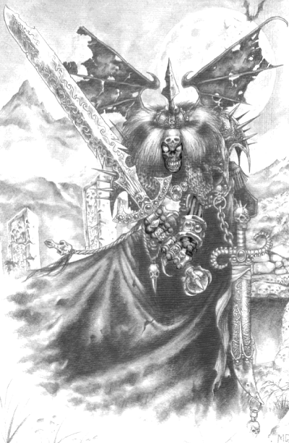
A renegade Wight and his minions have been invading and terrorising local villages in the dead of night. Affected by the raw power of Chaos Warpstone, the Wight’s bones have turned completely black, and he has gone insane with unquenchable bloodlust. Other undead affected by the Warpstone have also undergone strange transformations, such as horn growth or hairy bones. Thought an unstoppable force by many of the townspeople, the Warriors arrive on the scene to prove them wrong. The Wight’s lair, a nearby dungeon, is only a week’s travel from the settlement; the Warriors head off immediately.

SPECIAL RULES

Roll once on the Hazard Table to represent the week’s travel to get to the dungeon. Then play the adventure as normal. Upon reaching the Objective Room, do not roll for Objective Room Monsters. Place the Black Wight at the rear of the room; he will move down and attack the Warriors in his turn as normal. Roll three times on the first table to determine what Monsters are in the Objective Room. Then roll on the second table for each group to determine what mutation(s) they possess. Each group of Monsters will possess the same mutation – don’t roll for them separately!

D6 | Monster | Number
1 | Vampire Bats | 2D6
2 | Tomb Guardians | 1D3
3 | Zombies | 1D6
4 | Ghouls | 2D6
5-6 | Skeletons | 2D6

D6 | Mutation | Ability
1 | Bloodlust | Frenzy 6+
2 | Horns | Impale 6+
3 | Quick Reflexes | Dodge 5+
4 | Tough Skin/Bones | +1 Toughness
5 | Extra Leg | +1 Movement
6 | Hairy | -

 | The Black Wight
Wounds | 20
Move | 4
Weapon Skill | 3
Ballistic Skill | -
Strength | 3
Toughness | 4 (6)
Armour | 2
Initiative | 3
Attacks | 1
Damage | 2D6
Gold | 500

ENEMY’S WS 1 2 3 4 5 6 7 8 9 10
The Black Wight 2 3 4 4 4 4 5 5 5 6

The Black Wight
Fear 7; Frenzy 5+.

CONCLUSION
When the Warriors have managed to kill the Black Wight and his followers they are rewarded by the villagers with 1D3 x 100 Gold each. Because the villagers are farmers, they are give the Warriors 1D6 melons each from their crops; treat a melon in exactly the same way as a provision.

