

·THE EVIL DR BALTHAZAR·

by Andrew Brockhouse

Location: The Old World Battle-Level: 1-2 Objective Room: Throne Room of Death

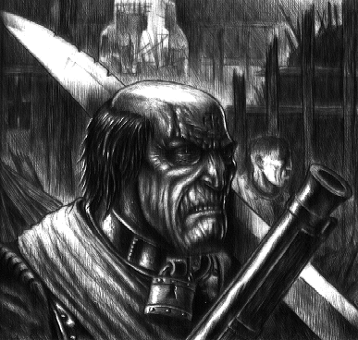
Dr Balthazar has a reputation for being eccentric. There isn’t a night that goes by without him conducting some sort of experiment in his castle on the hill. But lately, residents have had enough. For a few weeks now, children of the town have been disappearing. Grief stricken parents originally thought that wolves might have been to blame, but witnesses say that they have seem Dr Balthazar roaming the streets at night. Coupled with the terrifying screams of pain that have been emanating from the castle, people have become extremely suspicious of Dr Balthazar.

The Warriors are just passing through when they learn of the townspeople’s suspicions. Fearing however that it is too late for the poor children, the Warriors agree to go to the castle in a bid to stop the evil Dr Balthazar and his crazy experiments.

SPECIAL RULES

Play the adventure as normal until the Objective Room is reached.

Bodies of slain children, horribly disfigured lay strewn around the room. The Warriors are sickened by what they see. Suddenly they see Dr Balthazar at the rear end of the room, casually sitting on his throne. “Oh, I see you have come. Hopefully not to kill me, as that would prove very foolish…” The room is suddenly filled with hordes of Monsters.

Roll on the Objective Room Monster Table as normal, and place Dr Balthazar on the throne at the rear of the room. He has the following stats.

 | Dr Balthazar
Wounds | 8
Move | 4
Weapon Skill | 3
Ballistic Skill | 5+
Strength | 5
Toughness | 5
Armour | -
Initiative | 3
Attacks | 1
Damage | 1D6
Willpower | 2
Gold | 500

ENEMY’S WS 1 2 3 4 5 6 7 8 9 10
Dr Balthazar 2 3 4 4 4 4 5 5 5 6

Dr Balthazar
Shapeshift.

Shapeshift
Dr Balthazar has been experimenting on himself and has somehow gained the ability to Shapeshift. However, he has no control over the change and does not know when and if it will happen. At the beginning of the Monsters’ Phase, roll 1D6. On a 6 he has morphed into one of the following Monsters (roll 1D6).

1 | Black Orc
2 | Witch Elf
3 | Nightmare
4 | Harpy
5 | Ogre
6 | Minotaur

Note that he gains full Wounds each time he Shapeshifts according to the Monster he has morphed into. He also gains all of the Special Abilities of that Monster.

Completion
If the Warriors manage to kill Dr Balthazar they return to the city with sad news for the parents of the dead children. Due to the circumstances the Warriors decide not to enquire about the possibility of a reward.

