

·THE FEARSOME RINGS·

by Andrew Brockhouse and Nick Ruffin

Location: The Old World Battle-Level: 1-2 Objective Room: Any

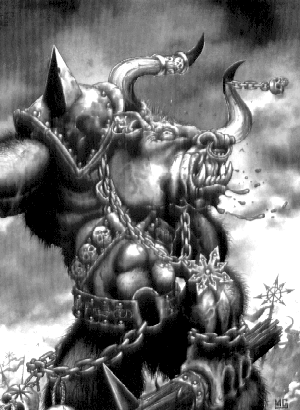
The Warriors hear that late last night the twin Rings of Ikiburu were stolen from the King’s Treasury. Witnesses reveal that they saw the shadowy shape of two hulking great beasts leave the scene moments later. The rings are of great sentimental value to the King, so he has asked the Warriors to retrieve them. They have tracked the beasts for days until their footprints stop at the entrance to a nearby dungeon.

SPECIAL RULES

Play the adventure as normal. Upon reaching the Objective Room the Warriors will encounter 2 Minotaurs with 2 Snotlings as pets. Also, make 1 roll on the Monster Table to determine what other beasts are in the room. The Minotaurs apparently stole the rings to use as nose rings in a fashion statement to make them appear more fearsome. And it worked – the Minotaurs have 1 extra point of Fear for this battle.

CONCLUSION

If the Warriors kill the Minotaurs they retrieve the rings and return them to the King who gives them a reward of 1 Treasure Card each from his Treasure Chamber.

