

THE KILLER CA-DANE

by Ben Head

Location: The Old World Battle-Level: 2-3 Objective Room: Any

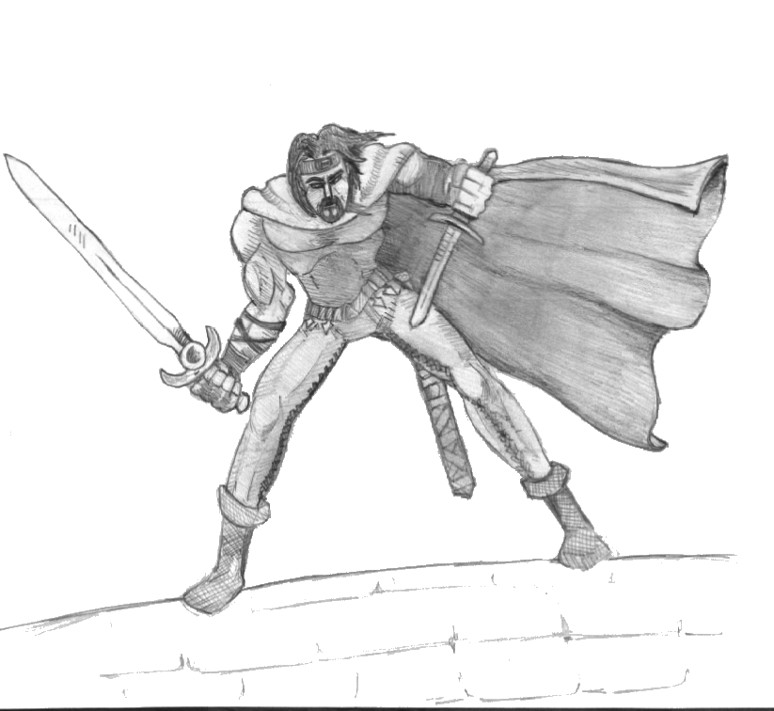

Called to the grand court of Altdorf by Emperor Karl Franz himself, the Warriors are greeted with grim news. The Emperor tells them of a terrible killer on the loose within Altdorf itself. Preying on the weak, wielding a sacrificial dagger, and keeping to the shadows he has been increasingly difficult to catch. But three days ago he was hit by three arrows, shot from the royal archers, and tumbled into Altdorf’s mighty Reik, where he was swept from view. He was thought dead, but he was seen killing again the following night with no apparent injuries. Being chased out of the city by the royal guard, he made his way to a nearby set of caves that eventually led to a dungeon. The guards were attacked by hideous beasts and few escaped back to report the information. This is when the Warriors are asked to help. They are to go to the dungeon and kill him, bringing back his dagger as proof to the Emperor. Any treasure within the dungeon may be kept by the Warriors and when they return to Altdorf they will each receive 350 gold for their services, but only if they have the dagger.

SPECIAL RULES

Play this Dungeon as normal with the following changes.

When a battle occurs adjacent to an unexplored board section then roll 1D6. On a 1-3 the killer Ca-Dane is lurking around the doorway of the unexplored area and at the start of every Monsters’ Phase he throws a dagger at a random Warrior, which hits on a 3+ inflicting 1D6+1 damage. Once the battle is finished he runs off into the darkness.

When entering the Objective room place Ca-Dane at the back (also roll normally for Objective Room Monsters). At the start of every Monsters’ Phase he throws a dagger at a random Warrior, which hits on a 3+ inflicting 1D6+1 damage, unless pinned by a Warrior, in which case he fights with the following statistics. When the Warriors get close enough they see that he is a zombie, although he seems larger and faster than any they have seen before.

Ca-Dane
Wounds 12
Move 4
Weapon Skill 3
Ballistic Skill 3+
Strength 3
Toughness 4
Armour -
Initiative 3
Attacks 1
Damage 1D6
Gold 100

Ca-Dane Special Rules
Armed with Sacrificial Dagger (Ignores armour on a 6+ to hit); Fear 3; Ca-Dane’s Plague

Ca-Dane’s Plague
Ca-Dane also is infested with a plague and every model who stood adjacent to him in the battle must make a roll of 1D6 once the battle is finished. On a 1 they have contracted the plague and must be healed at the next settlement for 150 gold x Battle-Level or die a horrible, painful death.

Completing the Objective Room
It is only now that the Warriors see a shadow at the far wall and hear the opening and closing of a secret door, one that they cannot re-open. The body of Ca-Dane is gone! They must now return to the Emperor. If one of the Warriors was standing adjacent to Ca-Dane when he died then he grabs the dagger. Otherwise they must return to the Emperor empty handed. Whatever happens, gain Objective Room treasure as normal.

