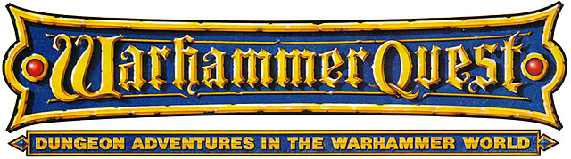

·THE KRAKEN AWAKES·

by Andrew Brockhouse

Location: The Old World Battle-Level: 3-5 Objective Room: Any

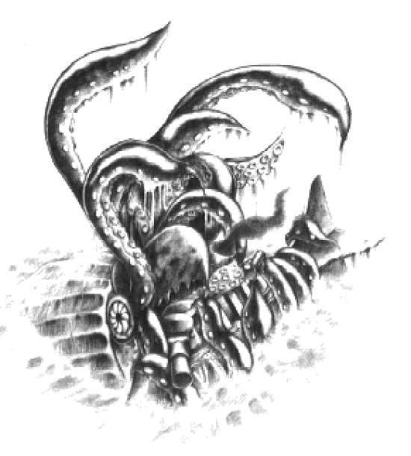
The Warriors are drinking heartily in the local Waterfront Tavern (do they ever go anywhere else?) when the door suddenly slams open. A bedraggled man is standing in the doorway, clutching the door frame with both of his hands, his face a deathly white.

“I’ze seened it I tellz yoo!” he croaks, eyes darting around the room madly. “I’ze seened it and its coming to gits yoo!”

The man lurches into the tavern and collapses at the feet of the Warriors’ table. One of them leans down to check if the man is dead when he leaps to his feet.

“Yes I has seened it! ‘Twas a hideous beast, more than 100 feet long and tentacles as thick as a horse!” The man keels over onto the edge of the Warriors’ table, sending it flying up into the air; the Warriors’ drinks sail across the room and land on a big burly gentleman.

“Oi!!! Woz that you wot dun this?” he bellows to the Warriors who are whistling nonchalantly and trying to tidy things up a little.

“Oi!!! I is talking to yous. So it’s a fight yous be wanting no?” And with that he throws an empty mug across at the Warriors, who duck out of the way. The mug flies directly into the face of a cowled figure in the corner of the room who slowly rises to his feet and walks casually over to the burly man. Raising his fist he punches him right in the face. Perhaps more shocked than anything else, the burly man reels back and trips over a serving girl, before drunkenly stumbling to the next group of seated patrons and collapsing in their lap.

And then it starts…

Needing no excuse for a fight, the rest of the bar patrons pick up any thing they can lay their hands on and leap into the fray, fists flying. The Warriors take this opportunity to leave when suddenly the old man pulls himself off up the floor.

“Big beady eyes, as dark as night I tellz yoo!” he offers, before collapsing once more. Leaving him there, the Warriors retreat from the barroom brawl into the safer streets of the harbour.

Taking the scenic route back to the inn, the Warriors are walking along the docks when without warning an enormous mass rises slowly from the ocean, waving eight thick tentacles around. The Warriors have heard tales of the legendary Kraken, but have never seen one until now! The Kraken pauses as if studying its surroundings before sinking beneath the surface of the ocean once more.

Just then a wiry looking man wearing a white coat runs up to the Warriors. “Did you see it? Did you see it?” he babbles. He looks the Warriors up and down studiously. “You fellows look the adventuring type. What say you to a bit of a treasure hunt?”

Obviously the Warriors are interested, so the man continues. “Tales have been told of a huge Kraken living under the sea, guarding a treasure of an ancient shipwreck. No one has been able to swim down to such depths to search for this treasure… until now,” he says mysteriously.

Just as the Warriors are about to ask him what he means the man beckons them to follow him to his “research laboratory”. Once inside, the man who introduces himself as Jacques Cousteau, shows the Warriors his latest invention, what he calls “scuba gear”. It consists of a glass sphere helmet-type item connected by a long hose to a large steel canister with straps. It allows whoever wears it to breathe underwater for a limited period of time. The air is fed into the helmet by the hose, and heavy steel boots weigh the Warriors down so they don’t float to the surface of the ocean. To rise to the surface, all the Warriors have to do is remove the heavy boots and they will float upwards. Jacques was experimenting with four sets of the scuba gear apparatus hoping to recruit some mighty adventurers like the Warriors to dive down onto the seabed and search for the treasure. Unfortunately, each time he brought up the subject of the Kraken everyone was scared off.

The Warriors are not so cowardly though and agree to search for the treasure. Handing them the four sets of scuba gear the scientist gives them a rough map of the approximate location of the shipwreck, and the Kraken. Eager to see what they can find, the Warriors head back to the docks and prepare for the adventure of a lifetime!

SPECIAL RULES

Each Warrior straps the scuba gear onto his back and dons the heavy boots. Because of the glass sphere helmet the Warriors may not use any type of helmet or mask for this adventure. In addition, potions or food may not be consumed, so the Warriors will have to rely on bandages and spells for their healing! Boots also may not be worn due to the steel boots the Warriors are wearing. Because of the heaviness of the boots, each Warrior has -1 Movement while on the seabed. If this takes him to 0 Movement then he will not be able to take part in this adventure. In addition after each use of a Magic Item (not weapons or armour) roll 1D6. On a roll of 1 the item has become waterlogged and may not be used for the rest of the adventure. Fortunately there is enough air in the scuba gear to last an entire adventure.

Because the location of the shipwreck is miles away from the harbour, the Warriors must sink down to the bottom of the sea and follow the map. Roll 1D6+4 times on the following table to represent their travels:

Undersea Hazards Table

Roll 2D6 for Underwater Hazards.

2 Stumble
A random Warrior stumbles on loose ground and falls over losing 1D6 unmodified Wound. Roll 1D6. On a roll of 1 his glass helmet develops a crack. At the beginning of each turn from now on roll 2D6. On a roll of a double 1 the Warrior’s helmet has shattered and he drowns before he can get back to the ocean’s surface for air.

3 Rip
A random Warriors air hose rips on a sharp rock. If the Warriors have any bandages they may attempt to wrap one around the hose to seal it back together. Roll 1D6. On a roll of 1 or if the Warriors have no bandages, surprisingly this crude method does not work and the Warrior drowns before he can swim to the surface of the ocean for air.

4 Jellyfish
Masses of purple jellyfish suddenly envelop the Warriors. Roll 1D6 for each Warrior.

1 The Warrior takes 2D6 unmodified Wounds due to the jellyfishs’ poisonous sting attack. If a Warrior is reduced to 0 Wounds from a jellyfish attack then treat it as being Poison.

2 The Warrior takes 1D6 unmodified Wounds due to the jellyfishs’ poisonous sting attack. If a Warrior is reduced to 0 Wounds from a jellyfish attack then treat it as being Poison.

3-5 The jellyfish pass by without harming the Warriors.

6 One of the jellyfish decides that the Warriors glass helmet looks enticing and attempts to mate with it. This does not affect the Warrior though who casually flicks the jellyfish off with his hand.

5 Monsters
A passing group of Monsters takes a particular interest in the Warriors. Roll on the Monster Table below and fight a battle.

6 Giant Clam
Stupidly, a random Warrior steps into an open clam that slams shut on his leg, causing 1D6 unmodified Wounds. The Warriors may attempt to help him force it open to free his leg. The Warrior must roll 1D6 and add his Strength and score 10 or more. Each assisting Warrior contributes +1 to the roll.

7 Fish Shoal
A shoal of (1D6)

1 Three-eyed fish
2 Seahorses
3 Horned Sea Urchins
4 Gumblejacks
5 Sunfish
6 Rainbow Fish

swim past the Warriors.

8 Sea Current
The Warriors are picked up by the sea current and swept along. Roll 1D6.

1-2 The current was unfortunately heading in the wrong direction. The Warriors are now further away from the ancient shipwreck. Roll another 1D3 times on this table.

3-6 The current sweeps the Warriors along the seabed. They may subtract –1 roll on this table.

9 Pearls
The Warriors discover a scattering of Oysters on the seabed. If they wish to they may open the oysters to see if any contain pearls. There are 2D6 Oysters in total; one will house a pearl on a 4-6. Each pearl can be sold in a Settlement for 50 Gold.

10 Dolphins
A group of Dolphins swim past the Warriors, playfully twirling and leaping around and generally creating a serene atmosphere. A random Warrior gains +1 Luck for this adventure only.

11 Buried Treasure
A Warrior’s foot catches on something. Looking down, he finds that it is an old treasure chest half buried. Dragging it out of the sandy seabed the Warriors realise that it is rusted shut with age. Each Warrior may attempt to open the chest by passing a Strength test of 9 or more. For each Warrior that succeeds, there will be 1 Treasure Card in the chest.

12 Shipwreck!
The Warriors stumble upon a shipwreck. Roll 1D6 to determine what seafaring vessel had the misfortune of sinking.

1 Nurgle Plagueship
A Nurgle Plagueship has shipwrecked here, causing the surrounding area to wither and decay. Each Warrior takes 1D6 unmodified Wounds due to the magical aura of stench.

2 Bane Tower of Tzeentch
This strange chaos vessel still emanates vile chaos magic. A random Tzeentch spell is cast on the Warriors as soon as they encounter this vessel. If something is cast requiring the Warriors to somehow dispel the spell, a successful Willpower test of 7 must be passed. One dispel roll is allowed per roll on the Undersea Hazards Table.

3 Pygmy Canoe
There is nothing to salvage from this bark canoe.

4 Dwarf Ironclad
A huge hole in the hull of this vessel probably caused it to sink almost immediately. Unfortunately anything that might have been useful is rusted and decayed beyond repair.

5 Empire Greatship
This mighty ship must have been the once proud flagship of Karl Franz’s fleet. If the Warriors venture further into the hold roll 1D6.

1-3 The Warriors find nothing of any value.

4-6 The Warriors discover a great treasure chest containing assorted jewels. The Warriors may each grab a handful of jewels worth 1D6 x 100 Gold each.

6 Ancient Ship
The Warriors have found the ancient shipwreck they were searching for! Read the appropriate section below.

Shipwreck
Crusty barnacles cover the hull of the shipwreck entirely and rotted timbers hang loosely suspended by entwined seaweed. The shipwreck is ominously silent, save for the occasional creak as it shifts on the sandy sea bottom.

Treat the shipwreck as a dungeon; that is, set up the Dungeon deck up normally. Only instead of a Dungeon the Warriors will be exploring an ancient shipwreck. Just pretend that each Dungeon Room is a room in the ship and Passageways are hallways etc. The Objective Room can be a mighty banquet hall or something similar.

If any Monsters are encountered, instead of rolling on the normal Monster Tables, use the following tables instead. Normal Monsters such as Orcs and Goblins and Lizardmen cannot breathe underwater and thus the Warriors will encounter only Monsters with no need for air.

2D6 | Monster | Number
2 | Ghosts | 1D6
3 | Sharks | 1D6
4 | Mummies | 1D3+1
5 | Wight Lord  Wights | 1  1D6
6 | Giant Crab | 1
7 | Wraiths | 1
8 | Tomb Guardians | 1D6
9 | Piranha | 2D6
10 | Killer Whale | 1
11 | Manta Rays | 1D6
12 | Zombies | 2D6

If at any time during the adventure a Warrior is reduced to 0 Wounds roll 1D6. On a roll of 1 he falls on his glass helmet and it develops a crack. At the beginning of each turn from now on roll 2D6. On a roll of a double 1 the Warrior’s helmet has shattered and he drowns before he can get back to the ocean’s surface for air.

Objective Room

Upon reaching the Objective Room the Warriors recoil at the sight of such an enormous beast. Perhaps the old man’s estimate of 100 feet was slightly exaggerated, but nonetheless the Kraken is absolutely huge.

The Kraken’s body takes up the back middle 8 squares of the Objective Room in a column 2 squares wide, with his long tentacles reaching into the squares the Warriors are standing on, from the front two squares of the Kraken, no matter where they are in the room. (see Figure 1 below for an example) Do not roll for other Objective Room Monsters – the Warriors will be hard pressed to defeat this monstrous beast as it is!

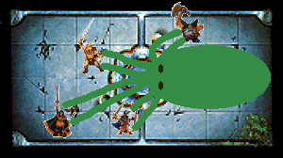
Fig. 1 (Kraken placement diagram)

The Kraken, although he has Movement will not move for this combat, preferring to remain guarding his home from the intruders. Each turn, if a Warrior is standing adjacent to the body of the Kraken, he may either attack it or the tentacles attacking him. There will be 2 tentacles attacking each Warrior each turn except if the Warriors have destroyed them, in which case the tentacles will spread out and attack the Warriors according to the normal ‘one-on-one’ rule. Warriors and Monsters cannot move through squares containing tentacles unless they are first destroyed. When all the tentacles are destroyed the Warriors will have to destroy the body of the Kraken before they can claim victory and the treasure.

If the Kraken’s body is killed there is no need to destroy the remaining tentacles, as they will drop to the ground.

After the Kraken’s death, the Warriors notice chests upon chests spilling over with all manner of fabulous and treasure. Roll on the following table for each Warrior to determine what they find.

1 Gold
The Warrior finds 1D6 x 100 Gold.

2 Gems
The Warrior finds 1D6 large gems worth 1D6 x 30 Gold each.

3 Treasure
The Warrior finds a piece of treasure. Take 1 Dungeon Room Treasure Card.

4 Ancient Sea Charts
The Warrior finds 1D6 old sea charts detailing the location of ancient cities thought lost centuries ago. Each map will fetch 150 Gold at the mapmaker.

5 Museum Artefacts
The Warrior finds many statues and ancient relics that he can sell to the Museum of Antiquities in the Old World. There are 1D6 relics that the Warrior gains 1D3 x 100 Gold each for.

6 Fabulous Treasure
An epic find awaits the Warrior when he opens the chest. Take 1 Objective Room Treasure Card.

Conclusion

The scientist is delighted when told that his inventions work perfectly. He is even more pleased that the Warriors located the ancient shipwreck and the treasure hordes. He reveals that now he will start up his own business and offer guided tours to anyone that wants to see the ancient shipwreck and the dead body of the legendary Kraken, killed by mighty adventurers.
MONSTERS OF THE UNDERWATER REALM

Shark
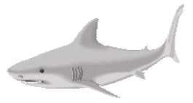
Wounds | 14
Move | 6
Weapon Skill | 4
Ballistic Skill | -
Strength | 4
Toughness | 4
Armour | -
Initiative | 4
Attacks | 1
Damage | 1D6
Gold | 190

ENEMY’S WS 1 2 3 4 5 6 7 8 9 10
Shark 2 3 3 4 4 4 4 4 5 5

Shark
Bloodlust; Swim

Bloodlust
At the first sign of blood, a Shark will go into a frenzied bloodlust. The first time a Warrior is injured in the combat the Sharks will detect his blood in the water and go into a feeding frenzy. Each Shark in the combat gains +1 Attack for the remainder of the combat.

Swim
Some Monsters are able to Swim, and thus can move around the board with a greater degree of freedom. Monsters that can Swim may move to any empty square on the board within their Movement range, ignoring all obstacles in their way.

Monsters that swim may not be pinned in combat and may change their target each turn. Draw a Warrior counter at the start of each Monsters' Phase for each swimming Monster to determine which Warrior it attacks. (If there isn't an empty square next to the intended victim, draw again.)

Manta Ray
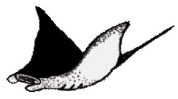
Wounds | 10
Move | 6
Weapon Skill | 3
Ballistic Skill | -
Strength | 4
Toughness | 4
Armour | -
Initiative | 4
Attacks | 1
Damage | 2D6
Gold | 150

ENEMY’S WS 1 2 3 4 5 6 7 8 9 10
Manta Ray 2 3 4 4 4 4 5 5 5 6

Manta Ray
Swim.

Piranha
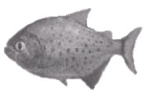
Wounds | 2
Move | 8
Weapon Skill | 2
Ballistic Skill | -
Strength | 2
Toughness | 1
Armour | -
Initiative | 6
Attacks | 1
Damage | 1D6
Gold | 30

ENEMY’S WS 1 2 3 4 5 6 7 8 9 10
Piranha 3 4 4 4 5 5 6 6 6 6

Piranha
Ambush, Magic A; Gang Up; Swim.

Giant Crab
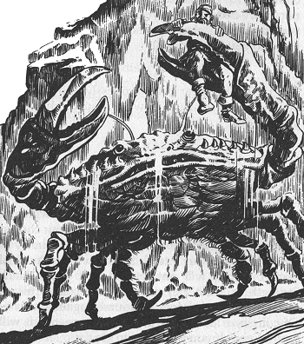
Wounds | 35
Move | 4
Weapon Skill | 4
Ballistic Skill | -
Strength | 5
Toughness | 5 (7)
Armour | 2
Initiative | 3
Attacks | 3
Damage | 2D6
Gold | 580

ENEMY’S WS 1 2 3 4 5 6 7 8 9 10
Giant Crab 2 3 3 4 4 4 4 4 5 5

Giant Crab
Sharp Pincers.

Sharp Pincers
The Giant Crab has a viciously sharp set of pincers that cleave through the sharpest of armour with ease. Therefore ignore all armour when calculating damage against a Warrior.

 | Killer Whale
Wounds | 30  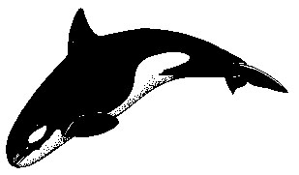
Move | 6
Weapon Skill | 3
Ballistic Skill | -
Strength | 5
Toughness | 5
Armour | -
Initiative | 3
Attacks | 2
Damage | 3D6
Gold | 620

ENEMY’S WS 1 2 3 4 5 6 7 8 9 10
Killer Whale 2 3 4 4 4 4 5 5 5 6

Killer Whale
Ram; Swim.

Ram
The Killer Whale is a huge hulking beast that can swim directly at a Warrior and knock him flying. Before attacking each turn roll 1D6. If the result is a 6 then the Killer Whale has slammed the Warrior to the ground and he misses out on his next turn. He is counted as being prone. The Killer Whale still gets to make an attack this turn against the Warrior though, but with none of the usual advantages for attacking a prone Warrior.

 | Kraken Body | Kraken Tentacle  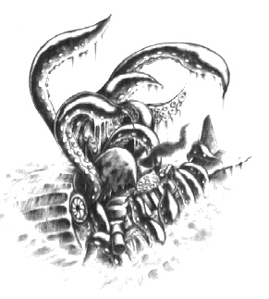
Wounds | 40 | 12
Move | 6 | -
Weapon Skill | 3 | 3
Ballistic Skill | - | -
Strength | 5 | 4
Toughness | 4 | 4
Armour | - | -
Initiative | 3 | 5
Attacks | 2 | 1
Damage | 3D6 | 1D6/2D6 (6+)
Gold | 800 | -

ENEMY’S WS 1 2 3 4 5 6 7 8 9 10
Kraken Body 2 3 4 4 4 4 5 5 5 6
Kraken Tentacle 2 3 4 4 4 4 5 5 5 6

Kraken Body
Ink Squirt; Swim.

Kraken Tentacle
Dodge 6+; Snare.

Ink Squirt
To confuse it’s enemies, the Kraken squirts out a stream of black ink to make it harder to be hit. At the beginning of the turn roll 1D6. On a roll of 5-6 the Kraken has squirted ink into the surrounding water. All Warriors are at –2 to hit this turn and –1 to hit the following turn before the ink disperses.

Snare
The Kraken will attempt to snare the Warriors in its tentacles and drag them into its gaping toothed maw. If an attack by a tentacle hits a Warrior, instead of doing damage it wraps itself around the Warrior and pulls him into one of the 4 squares in front of its body. Here, the Kraken makes an attack against the Warrior. Since a Monster can only attack once per turn, wait until after all tentacles have attacked before attacking with the Kraken’s body. Choose a random Warrior in the 4 adjacent squares to its mouth to attack. If a Warrior is already in one of the 4 ‘bite attack’ squares either by his own choice, or by being dragged there, any tentacles attacking him will do normal damage.

