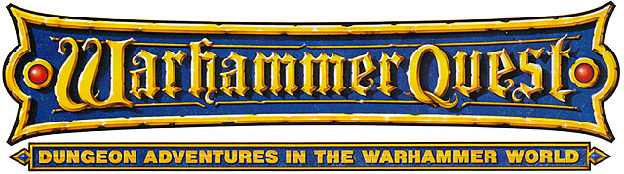

·THE LOST CITY OF AUTLOXOTL·

by Andrew Brockhouse

Location: The Old World & The Lost Kingdoms Battle-Level: 1-3 Objective Room: Any

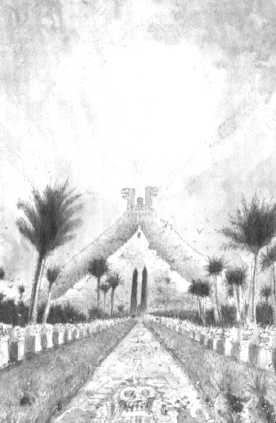
The Lost City of Autloxotl is a two part campaign. The first part of this campaign is The Map, the second part is The City.

Part 1 – The Map

In the year 1492, Tilean explorer Marco Columbo made an epic voyage to Lustria. It has been known for many centuries that he discovered an enormous Lizardman city hidden away in the immense density of the jungle. It was reported to be one of the most magnificent places that he had ever set eyes upon. Although Marco had very little time to explore without alerting the Lizardmen to his presence he is said to have been awed at the vast amount of riches he saw. He eventually returned to Tilea, where he lived the rest of his life surrounded by his wealth. For many hundreds of years after his death, would-be explorers set off to Lustria in search of this fabled city, however none could find it. Some men returned empty handed, a handful of gems their only find – most never returned at all.

A few weeks back, talk had began of a merchant convoy that had perished while in Lustria. The merchant in charge of the convoy, Abu Hassan apparently stumbled into a fabulous Lizardman city while fighting off hordes of Skinks. Abu quickly sketched a map along with directions and sent a messenger back to the Old World, determined that if he survived he would return to gather the treasure from this city. Unfortunately, due to the sheer number of Skink warriors, Abu Hassan and his convoy perished. The messenger, Shez, made it safely back to the Old World, the map intact. Perhaps the lost Lizardman city would finally be found!

Unfortunately, on the night that Shez returned, his room at the Standing Oak Inn where he was staying was broken into by bandits; they cut his throat while he slept and made off with his belongings back to their lair. The Warriors have found out that the bandit’s lair is in a nearby dungeon and must travel there to retrieve the map, hopefully before the bandits realize the significance of their haul.

SPECIAL RULES

Play this adventure as normal until the Objective Room is reached.

The Objective Room will be the bandit’s lair. Instead of the normal Objective Room Monsters the Warriors will have to fight the bandits if they wish to reclaim the map. There will be 2D6+4 bandits along with the bandit leader. Half of the bandits will be armed with swords, while the other half will fire their bows.

 | Bandit | Bandit Leader
Wounds | 3 | 10
Move | 4 | 4
Weapon Skill | 3 | 4
Ballistic Skill | 5+ | 4+
Strength | 3 | 4
Toughness | 3 | 3 (5)
Armour | - | 2
Initiative | 3 | 5
Attacks | 1 | 2
Damage | 1D6 | 1D6
Gold | 30 | 70

ENEMY’S WS 1 2 3 4 5 6 7 8 9 10
Bandit 2 3 4 4 4 4 5 5 5 6
Bandit Leader 2 3 3 4 4 4 4 4 5 5

Bandit
-

Bandit Leader
-

Victory!

Once the bandits and their leader are dead the Warriors search the chests of the bandits’ treasure for the map. Eventually they find it, screwed up at the bottom of one of the chests. Suddenly they realise that the parchment they are holding contains no more than a few rough scribbles and words, not a map to the city as they were led to believe. However, one of the Warriors manages to read one of the words and recognises it from a map of Lustria as an ancient Pyramid Tomb City in Lustria. It looks like this is indeed a map then, although a rather crude one. The Warriors will need to find a ship heading for Lustria - it will take them many months to find the lost city following these directions. Before leaving, each Warrior may take 1 Treasure Card from the bandit’s treasure piles.

Returning to the Settlement

Upon returning to the Settlement, the Warriors receive instructions from the King to recover one or more of the sacred plaques which tell of the history of the city and return it so that future generations can learn about this ancient city.

Part 2 – The City

After the Warriors have arrived in Lustria and finished their business in the Seaport they must actually try to find the lost city using the crude map. Using the normal rules for wilderness travel, the Warriors can attempt once per week to locate the city, after travelling for a minimum of 4 weeks (it takes this long to reach the city one of the Warriors recognised on the map). At the end of each week thereafter roll 1D6. On a roll of 6 the Warriors have found the city - any other roll and they must continue for yet another week.

The City
The Lost City of Autloxotl stretches out in front of the Warriors for as far as they can see. However, although once it might have been a marvellous city, centuries have taken their toll – it now lies in ruin. As the Warriors enter the city, they can see what remains of the city. Ruined Skink barrios, once housing the majority of the Skink population of the city have been decimated by time. The streets are literally covered in rubble, making progress difficult. At last the Warriors come across the main Pyramid Temple, located in the centre of the city. If there is any treasure here, it will most likely be in the chambers below the temple. If the Warriors decide to investigate they could be rewarded with vast riches. If however, they are not ready for such adventure, they may return to the Old World and be hailed as heroes anyhow – the knowledge of the city’s location as valuable as any treasure.

Shuffle the dungeon deck as normal except add an additional 1D6 cards to the top of the pile to represent the vastness of the temple. The sacred plaques the Warriors are after are located in the Objective Room. At the end of the battle roll 2D6. This is how many plaques are still intact and the amount that the Warriors can transport back to the Old World.

Completion
The quest is over when the Warriors have returned to the Old World and presented the sacred plaques to the King. He will give the Warriors 200 Gold for each plaque.

