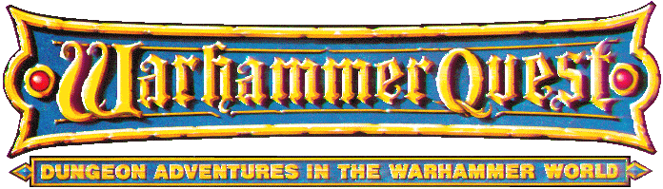

·THE SKY DUEL·

by Andrew Brockhouse

Location: The Old World Battle-Level: 1-10 Objective Room: Summoning Room

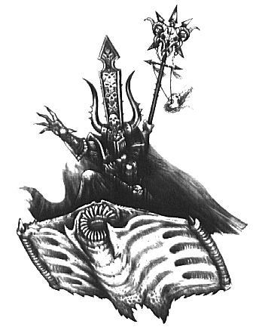

For many years the sacred spirit stones were the centrepiece of the crown jewels of Altdorf. They were given to the Emperor by the Wood Elf queen as a token of friendship in a ground-breaking truce between the two nations. Said to have the power to see beyond death, now they have been stolen by vile Chaos thugs on a raiding party through the city. The Warriors have been asked by the Emperor to retrieve them as the Wood Elf queen arrives soon for a tour of the city and will most likely want to see the stones. He offers to pay each Warrior 300 Gold for finding the stones.

SPECIAL RULES

Play this adventure as normal until the Objective Room is reached where the following text should be read:

A Chaos Sorcerer of Tzeentch stands in shadow at the back of the room. He is engrossed in something but looks up when the Warriors enter. “No doubt you have come for the stones, but to retrieve them you must first battle my minions.” He flicks his wrist and suddenly the Summoning Room is filled with hideous beasts. “Now you will pay for your interference!”

Do not place a miniature on the board to represent the Chaos Sorcerer. He is far too engrossed in his work to bother the Warriors while they are fighting. Depending on what Battle Level the Warriors are on, use the appropriate level Chaos Sorcerer from the Monster tables in the Roleplay Book. eg. At Battle Level 10 use a Chaos Sorcerer Lord.

Roll on the Monster Tables as normal for Objective Room Monsters.

Victory!

With surprise, the Chaos Sorcerer suddenly realises the Summoning Room is empty apart from the Warriors. “Well done! Obviously I have underestimated you. Fortunately I am prepared.” He pulls a lever on the side wall. With a grinding noise, the entire wall of the Summoning Room slowly rotates upwards, giving the Warriors a clear view of the entire valley outside. Before the Warriors can stop him, the Chaos Sorcerer leaps on a Flying Disc of Tzeentch and flies out of the room. The Warriors have failed!

Suddenly, one of the Warriors notices a pile of four other Flying Discs, conveniently stacked on top of each other in the rear corner. Now at least they have a chance of catching the Sorcerer!

The Chase

No boards are used for the next part of this adventure. Instead, a ruler with inches marked on it will come in handy.

Place the Chaos Sorcerer miniature on the table, 2D6 inches in front of the four Warriors, which themselves have been equally spaced. Depending on what Battle Level the Warriors are on, use the appropriate level Chaos Sorcerer from the Monster tables in the Roleplay Book. eg. At Battle Level 10 use a Chaos Sorcerer Lord. Randomly place 2D6 trees, scenery etc. suitable for a forest valley on the table around the Warriors and the Chaos Sorcerer. The Warriors can start off in any direction they choose. To simulate the speed of the chase, the scenery will actually be moved backwards instead of the Warriors being moved forward, although the Warriors still have the chance to gain on the Chaos Sorcerer. See the diagram below for placement of models etc.

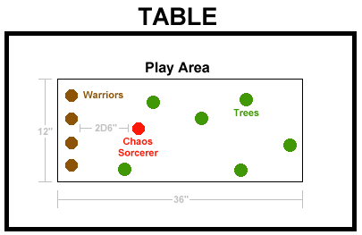

There will be no Unexpected Events occurring while the chase is in progress, although the Warriors must still roll for Power as normal.

During the Warriors’ Phase each piece of scenery moves backwards 6 inches. Scenery moving off the table edge is placed randomly on the opposite edge of the playing field. In addition, each Warrior can roll 1D3 and move forward the amount shown. However he may also choose to drop back a little in which case instead of rolling the dice he can move backwards up to 6 inches. If the Power dice comes up as a 1 then the Chaos Sorcerer has managed to fly faster than the Warriors and moves forward 1D6 inches himself. A Warrior can attempt to turn up to 45 degrees at the beginning of his turn before moving in an attempt to dodge trees and obstacles. If, however he is too slow and flies straight into something roll 1D6 and add his Initiative (subtract 1 for every other obstacle the Warrior has attempted to dodge this turn) :

Impact Table

1-2 The Warrior slams head first into the obstacle, splattering his brains all over the place. He is quite dead and no resurrection spell can bring him back.

3 The Warrior slams into the obstacle, causing himself 2D6 unmodified Wounds damage. If he is still alive he topples off the Disc to the valley below, taking a further 1D6 unmodified Wounds. He must now travel to the Settlement and await the Warriors.

4 The Warrior manages to break just in time to avoid hitting the obstacle. However the other Warriors are now such a distance ahead that it would be impossible to catch them. He must continue to the Settlement alone. Since he is on the Flying Disc he may subtract 2 weeks from travel.

5 The Disc gets caught up in the obstacle slowing the Warrior down. Next turn, move him back 6 inches with the scenery.

6 The Warrior attempts to dodge the obstacle and almost makes it. However, he clips the Disc on the edge, sending it flying off in another direction. Randomly choose a direction and roll 1D6. This is how many inches the Disc has veered off course.

7+ Just in time the Warrior manages to dodge out of the way. Place his miniature as close to the side of the obstacle as possible and continue the turn from there.

If a Warrior is not headed in a straight line up the table but instead has turned, when the scenery has moved back, move the Warrior 1 inch in the direction he is facing before rolling for collisions.

If any Warrior moves off the play edge he is considered to be out of the chase - take the miniature off the table. He will have to meet up with the other Warriors at the Settlement, although since he has the Disc of Tzeentch he can subtract -2 weeks from travel. Note that the Warriors can break off the chase at any time by leaving the play edge and allowing the Chaos Sorcerer to escape.

If any Warrior is adjacent to the Chaos Sorcerer at any stage, he may attempt to engage him in battle. However, subtract -2 from his to hit rolls as the Discs are speeding along at a rate which makes it hard for the Warrior to keep his balance. The Warriors may also fire any missile weapons at the Chaos Sorcerer with a -2 to hit as well. In addition to combat, the Warriors can cast spells and use magic items against the enemy - note that an inch counts as 1 square.

At the beginning of the Monsters’ Phase the Chaos Sorcerer will attempt to cast a spell although since he is concentrating on escaping from the Warriors roll 1D6. On a roll of 1-3 he fails to cast a spell this turn. He may also attack the Warriors as normal except with a -2 to hit penalty. If any Warriors are reduced to 0 Wounds they cannot perform any turns with their Disc - instead they may only travel in a straight line until healed. If any collisions occur treat the Warrior as having an Initiative of 1. The Chaos Sorcerer can also attempt to move out of the way of obstacles etc. If his path will take him directly into an obstacle then he will attempt to turn at an angle which will take him away from the obstacle. If somehow he crashes, roll on the impact table above. If any roll results in him falling off his Disc the Warriors can retrieve the stones from his body if he is dead. Otherwise he will vanish into the forest, never to be seen again.

If the Chaos Sorcerer makes it off the front edge of the play edge the Warriors’ quest will have failed.

Completion
The quest is over when the Warriors have killed the Chaos Sorcerer and regained the spirit stones which they find on his dead body.

