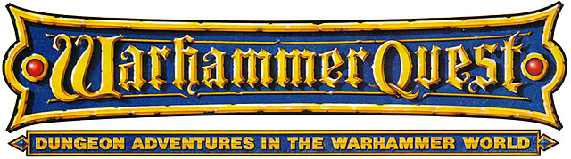

THE SYLVANIAN HORSEMAN

by Michael Brockhouse and Wendy Brown

Location: The Old World Battle-Level: 3-4 Objective Room: Great Hall

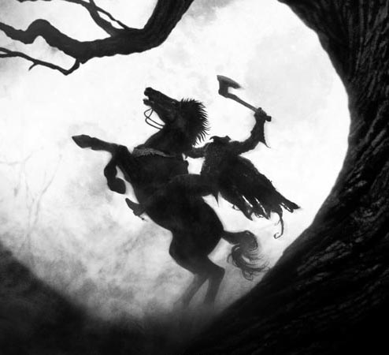

Even the Undead aristocracy of the night fears something. The Vampire Counts of Sylvania rule the dark, tainted lands with an iron grip of fear over the local populace. But there is one village even they won’t venture into. One village that fills each Vampire’s dead heart with a cold chill long thought forgotten. For within the tiny, farming settlement of Drowsy Willow, there is a dark haunted secret with plagues them: An Undead thing, which rides into the village each night, claiming victims for its own dark purposes. The Vampires fear its approach. They feel the malevolence deep within their chests. The creature, uncontrolled by either the dark warping forces of Chaos, or the powerful binding magics of the Necromancer, roams free within the haunted forests of Sylvania. The Vampires fear that which they cannot control or destroy.

The few commoners that remain in Drowsy Willow say the Undead rider charges into the village, its sword shining magically in the moon light. A dark crimson cloak adorns its neck, billowing out behind it in the dark cold wind. It wears a set of shiny black chain mail, and black steel gauntlets. No one has dared stand up to challenge this creature of the night. With terrible intent, the creature enters the village, kills a chosen villager and takes his severed head back to wherever unholy place it resides during the day. No one knows why the creature needs these heads, and no one dares find out. But the most remarkable thing about this Undead rider is the fact that he is so fast and so strong, and yet he has absolutely no head whatsoever. Even the mightiest Liche Lord will not survive long without a head. How does this vile creature remain so powerful after death without his main appendage?

It is upon a dark, foggy night that the Warriors enter the village of Drowsy Willow. Mist rolls in from the forest edge as the Warriors try to locate an Inn for the night. Doors and windows are bolted shut as the Warriors pass by, not a word spoken amongst them. The Innkeeper is a stocky fellow, balding and wearing a large white apron, covered in thick layers of grease. The Warriors settle down for the night. Suddenly, there is a horrendous scream from outside, and the pounding of hooves in soft mud. The Warriors grab their equipment and race downstairs. They shove open the Inn door to be greeted with a horrible sight. A pitch-black steed stands rearing back on its two hind legs, fiery red eyes burning with hatred. Upon its back sits a cruel mockery of a Paladin, his crimson cloak flowing outwards behind him. In one hand he wields a mighty two handed sword as if it were paper. Sparks of magic radiate around the blade, illuminating the grisly visage of a human head in his other hand. The Warriors gasp to see the rider has no head upon its broad shoulders.

With a cruel, slavering sneer, the dark steed takes off for the mists of the forest. The Warriors regain their composure and race to the stables, grabbing hold of the nearest horses. Mounting, they give chase to the strange spectre, following the churned mud footprints into the blackness…

SPECIAL RULES

The Warriors give chase to the Headless Horseman! Use the following rules to determine what happens.

Place as many long passageway board sections as you have in a formation similar to the diagram below.

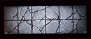
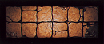

This represents the path the Warriors are following in their pursuit of the Horseman. Place the Warriors (mounted on steeds, therefore taking up two spaces each) on the first board section, closest to the start. Then place the Headless Horseman at the start of the second board section. The Horseman takes his turn first. Roll 1D6. On a roll of 1 or a 2, he has encountered an obstacle in his path and may only move 1D6 squares this turn. Otherwise, he can move his full Movement value (9 upon his steed). He then moves this many spaces forward. The Warriors then roll 1D6 and adds Initiative to see how far they can each move.

The object of the chase is to try and kill the Rider before he reaches his destination. However, this is never actually accomplished no matter how well the Warriors do. It is in their best interests to try and cause as much damage to the Headless Horseman before he reaches his hideout. During his move, if the Warrior reaches a space adjacent to the rider, he may make an Attack DURING or AFTER his move. For example, if he can move 7 spaces this turn, and the Rider is only 5 spaces away, he can move 5 spaces, make an Attack, and then finish his move. For every Attack the Warrior has, he can make one attack per square he is adjacent to the Rider. In the above example, the Warrior has 3 Attacks. He makes his first attack on square 5, which is adjacent to the rider. He can then make a second attack at square 6, and because he has a third attack and one movement left, he can move into the next square and make a final Attack. Note that Attacks are directed against the rider, not at the mount. Warriors cannot attack the Mount at all. Also note that the Warrior cannot make an Attack BEFORE he has moved. He must move at least one square before attacking the Headless Horseman. The Horseman, too, can make attacks against the Warriors using the same rules as above. However, he will always try and escape the Warriors as quickly as possible, not hover around and attack them. Missile weapons can be used against the Headless Horseman, but with a –2 penalty to hit, and may only be fired at the end of the Warrior’s movement turn, not during. Magic can not be used in this combat, as the words for powerful incantations are far from what the Warriors are thinking in this heated pursuit. The Headless Horseman’s stats are below, as well as his Steed’s.

 | Headless Horseman | The Horseman’s Steed
Wounds | 30 | 12
Move | 4 | 9
Weapon Skill | 7 | 3
Ballistic Skill | 6+ | -
Strength | 4 | 4
Toughness | 4 (6) | 3
Armour | 2 | -
Initiative | 6 | 4
Attacks | 3 | 1
Damage | 2D6 | 1D6
Willpower | 4 | 2
Gold | 750 | 250

ENEMY’S WS 1 2 3 4 5 6 7 8 9 10
Headless Horseman 2 2 2 3 3 3 4 4 4 4
The Horseman’s Steed 2 3 4 4 4 4 5 5 5 6

Headless Horseman
Armed with Electric Sword; Decapitation; Ignore Blows 6+; Magic Resistance 5+.

The Horseman’s Steed
Barge Aside; Breathe Fire 2; Hate All Living; Magic Resistance 6+.

Electric Sword

This powerful magic weapon the Headless Horseman uses sparks with electrical energy. Whenever the Horseman causes damage to a Warrior, all adjacent Warriors (to the Headless Horseman, not the Warrior) also suffer 1D3 unmodified Wounds due to magical sparks.

Decapitation
Whenever the Headless Horseman rolls a 6 to hit, roll 2D6. On a roll of a double 1, the Warrior has had his head severed from his body in one clean swoop. He is dead and cannot be resurrected.

Barge Aside
This ability may only be used during the chase with the Warriors through the forest. If for some reason, there is no space for the Headless Horseman to move forwards (the Warriors are blocking his path onwards.), the Steed will lower its thick skull and barge its way through to freedom beyond the Warriors. Move as many Warriors aside as necessary to make room for the Steed to charge through. This is quite an exertion, and the Headless Horseman must forfeit all his Attacks this turn simply to keep his Steed from slowing down. Each Warrior pushed out of the way also loses a single Attack next turn.

Keep track of how many board sections the Warriors race over, as you may need to reuse them. There are two ways for this chase to end.

1 The Warriors can do enough damage to the Horseman to force him to return to his hideout without the time to heal his Wounds.
2 The Warriors are too slow, and the Horseman returns to his hideout long before the Warriors get there, having more than enough time heal any Wounds he has received.

If the Warriors manage to cause at least 15 Wounds on the Horseman before he has passed the 20th board section, then they are hot on his tail, and manage to reach his lair literally a few seconds behind their target. When the Warriors next encounter the Headless Horseman in the Objective Room, he is severely wounded, and has only managed to heal himself back up to 15 Wounds. Also, he does not have the Ignore Blows 6+ ability.

If the Warriors do not cause at least 15 Wounds on him before he passes the 20th board section, then they are very far behind, and the Horseman manages to escape them and have plenty of time to heal himself, ready for the next battle in the Objective Room.

Treat the Dungeon as a normal adventure, except use the Undead Monster tables from The Catacombs of Terror if available. Once the Objective Room has been reached, roll for normal Objective Room Monsters in the usual way. What’s more, the Headless Horseman will be sitting astride his powerful steed at the back of the room. Remember to modify his stats, depending on how the chase finished. Remember that the Steed must be attacked first before the rider, as the default rules state.

When the Horseman is finally killed, the Warriors learn from scrolls and journals lying around on the floor that the Horseman was actually the ghost of a jilted Kislevite warrior who fell in love with a maiden from Dreary Willow. The maiden despised him though, and one night, while the warrior was staying at the Inn, writing a love note to express his feelings, his head was removed from his shoulders by the hateful maiden wielding a farming implement. A few weeks later, the raw forces of Chaos merged with stray dark necromantic powers of the Vampire Counts, causing the Kislevite warrior to rise from the grave and hunt down the woman whom killed him. He killed her and took her head, hoping it would fit his neck, since he could not locate his own. When it didn’t, he continued his reign of terror, desperately trying to find a head which fit his neck from citizens of Dreary Willow. Also from the journals, the Warriors find information that says the location of the Headless Horseman’s missing head.

When the Warriors return to the village, they locate the head hidden in a secret compartment of the maiden’s bedchambers. Sending a page boy with the head to the now safe dungeon, the Warriors relax, knowing that once the body and head are reunited, the Kislevite warrior can at last get peace. Each Warrior gets 50 Gold Pieces as a reward from the grateful mayor. The village is too small to support the appetites of the Warriors, so they decide to move on to a bigger city within Sylvania. This takes 1 Week travel to get there. The Warriors can now do as they wish within the settlement.

