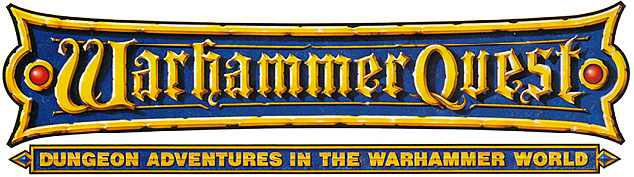

·THE TREATY·

by Ben Head & Andrew Brockhouse

Location: The Old World Battle-Level: 1-2 Objective Room: Food Hall

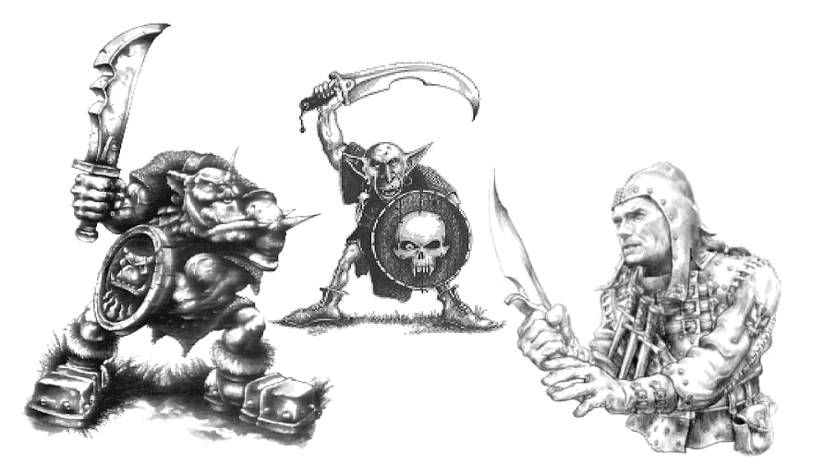

Rumours have been spreading around the city of an alliance forming between bandit groups of Orcs, Goblins and Humans. Apparently a treaty will be signed at a hillside hideout nearby this very night! Unrest has risen in the neighbouring towns and they have pooled their Gold to hire the Warriors to make sure the treaty is never signed. A mighty feast is being held to celebrate the forthcoming treaty. Seizing the opportunity to end this madness the Warriors travel to the hideout to break up the feast!

SPECIAL RULES

Play this adventure as normal until the Objective room is reached.

Objective Room

When the Warriors enter the Objective Room they interrupt the great feast. The three leaders of the different factions are at the head of the table, about to sign the treaty. At the end table, place an Orc Boss, a Goblin Big Boss, and a Bandit leader (stats below). Also place an Orc Shaman at the rear of the room up on the steps. Place the following Monsters around the various tables: 6 Orcs, 6 Goblins and 6 Bandits (stats below). The leaders will remain at the table until a Warrior targets them with a spell or a missile weapon, in which case they will then head after that Warrior.

 | Bandit | Bandit Leader
Wounds | 3 | 10
Move | 4 | 4
Weapon Skill | 3 | 4
Ballistic Skill | 5+ | 4+
Strength | 3 | 4
Toughness | 3 | 3 (5)
Armour | - | 2
Initiative | 3 | 5
Attacks | 1 | 2
Damage | 1D6 | 1D6
Gold | 30 | 70

ENEMY’S WS 1 2 3 4 5 6 7 8 9 10
Bandit 2 3 4 4 4 4 5 5 5 6
Bandit Leader 2 3 3 4 4 4 4 4 5 5

Bandit
-

Bandit Leader
-

Completing the Adventure

Once the Warriors have defeated the bandit groups, they find the treaty and tear it to shreds. The townsfolk pay the Warriors 200 Gold each for their services.

